DNS Setup

# HA Setup Using DNS

# DNS Setup:

* + 1. Select any DMS that can be used as DNS
    2. The file that must be used is bind_corporate.tgz.
    3. Copy the bind_corporate.tgz to the DMS that will be used as DNS and untar the file in /data of the DMS.
    4. Go to /data/bind_corporate/usr/local/bind/etc/named.conf and add the primary and Secondary MS IP address.

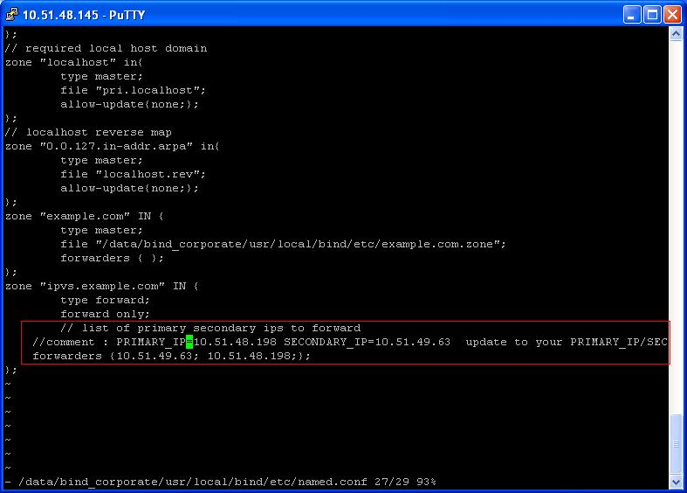

Figure 6: DNS Settings snapshot

* + 1. Run “/data/bind_corporate/usr/local/bind/sbin/named –c /data/bind_corporate/usr/local/bind/etc/named.conf”
    2. Run ps command on DMS running DNS to check if DNS up and running.

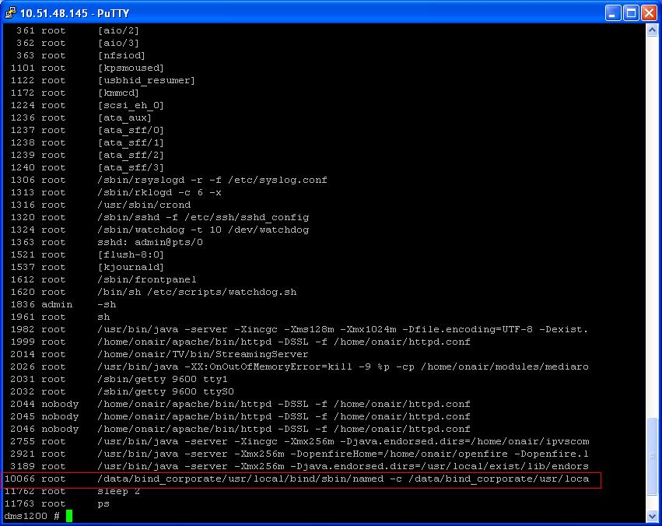

Figure 7: DNS Status Snapshot

* + 1. PC that is been used to run Admin UI should also point to the same DNS server. If not follow as shown in the picture.
    2. Select Local area connection , right click and select properties

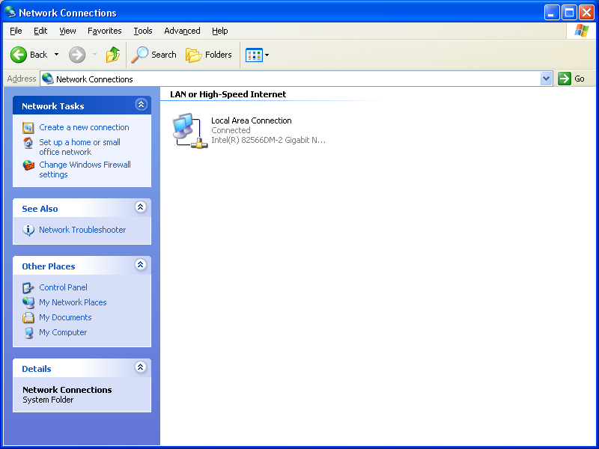

Figure 8: Local Area Connection

* + 1. Select Internet Protocol(TCP/IP) and select properties

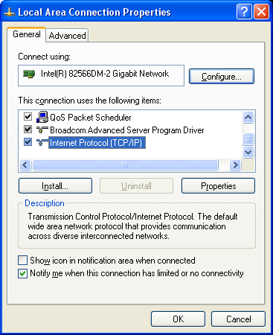

Figure 9: TCP/IP Properties

* + 1. Add the DNS server that is been used for HA as shown.

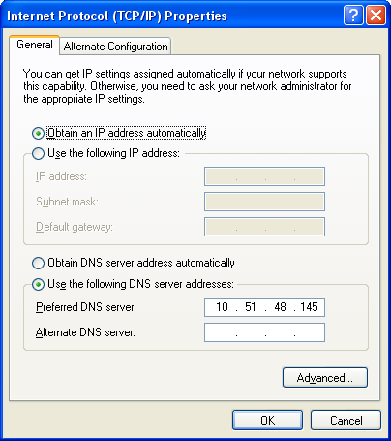

Figure 10: Obtain DNS IP